**An Analysis of the Marx-Biased Technical Change**

Chris Green

Econ 5529

May 20, 2018

**Introduction**

Through this paper will look at some of the original work done by Foley and Michl (1999). We will reproduce and update, the analysis done from the original analysis using the Extended Penn World Tables (EPWT 2.0). Along with looking at Foley and Michl’s work we will also look at a critique of their work produced by Deepankar Basu (1999), also using (EPWT 2.0). The analysis done in this paper will use the (EPWT 6.0); although there will be some variations in the way we produce our results due to the different techniques used in R code, and having data that has 16 more years of data from various countries.

The amount of change that technology has on our economy is hard to measure. Classical economist look at this in many different ways.

Luis Villanueva (2015) describes the view of classical political economists, Smith, Ricardo, and Marx long emphasized and incorporated the role of technical change as a central factor in a country’s economic growth and the long-run evolution of productivity. Smith’s insights focused on how the division of labor leads to increasing returns to labor and eventually higher economic growth. Ricardo incorporates social classes (rentiers, workers, and capitalists) and, in his chapter “On Machinery,” studies the impact of machinery on the well-being of the different classes of society. For Marx the competition among capitalist to reap the highest profits creates a powerful incentive for the adoption of production methods that use more capital and less labor, a technical change that is labor saving and capital using. Foley and Michl (1999) called this pattern “Marx-biased technical change” (MBTC).

As all the classical economist listed above, Smith, Ricardo and Marx see technological change as an advantage in production and its labor we will go deeper into all of these theories and see who gains from the higher productivity level and attempt to measure if profit is spread equally among individuals or if it is bring a massive amount of inequality.

**Variables**

The graph below was produced from data supplied by the economic policy institute. The data that starts being tracked in 1948 goes until 2016. Showing the amount of income (hourly compensation) for a worker (Wages and benefits). Productivity is a measurement of the whole economy. From the graph we can see that wages began to stagnate at 1973 compared to the productivity levels of the economy. This brings us to ask what could have the ability to continue to push productivity but slow workers’ wages.

*Table1*

The original study done by Foley and Michl (1999) and later done by Basu (2009) uses the following restraints.

Share of profits in production by $π≡1-w/x$

$$π≤π^{*}≡\frac{γ(1+x)}{γ-x}$$

Basu (2009) introduces a viability parameter $π_{i}^{*}$

$$π≤π_{1}^{*}≡\frac{γ}{γ-x}$$

The components $(γ,x)$ for growth can be found within the EPWT (6.0). The share of profits and viability parameter must be produced on our own.

The two new variables calculated out now can help us to measure rather or not the neoclassical theory of profit share is equal to the threshold identified by the viability condition. The theory stating that productivity will always equal the productivity of labor in the long run.

$$π=π^{*}$$

The MBTC view based around the idea that the marginal product of labor and wages will come out of ‘equilibrium’ stating the below:

$$π≤π^{*}$$

Where π* is the viability parameter and π is the share of profits in national income.

Foley and Michl (1999), the classical viability condition can be used to draw out competing, testable implications about observable variables in the economy. These competing testable implications refer, respectively, to the neoclassical and the classical-Marxian theory of distribution, where the neoclassical theory implies equality of the current wage rate and the marginal product of labour, while the classical-Marxian theory allows the wage rate to exceed the apparent marginal product of labour.

The original hypothesis is based around a visual and analytical inspection of rather or not π* > π. The results produced are based on plotting a 45degree line, the line of 45 degree angle is designed to show perfect income distribution. The line is upward sloping due to the fact that societies become more efficient over time and wealth is distributed evenly among everyone, is known as the Lorenz curve.

If most of the points from representing the various countries fell onto the 45 degree line this would support the neoclassical story of growth and distribution π*=π. Rejecting the hypothesis would provide evidence against the neoclassical view. Through my understanding of neoclassical economics I would not say this provides sufficient evidence against the neoclassical view if the null hypothesis is rejected. This is due to us not being able to measure if we are in the short-run for profit shares. For the individual company this would be an easier aspect to measure but within the macro economy this is a far harder measurement to make. With this information we can only say that the economy is not in the long run if it falls outside of the equilibrium.

**Expected results**

The original results previously produced were from EPWT 2.0. Initially, there was an attempt to remake the EPWT myself but, there were difficulties creating specific variables and merging different data sets. As with the original we will be producing results from 1963 until 2016. This is so we have the ability to see how much we have moved since 2000 as we expect the results to become more biased as technology began to come to the forefront of business far faster after 2000.

Our goal through this research is to have a better estimate of what has caused the split in [figure 1]. We see from this graph alone there is a clear spread in the productivity levels of people but we are looking at what is causing that issue and rather our not we have enough evidence to show that a significant amount of the stagnation in pay can be the result of technical change. The data we have available is ran from 1963 until 2014 while the prior experiment was ran from 1963 until 2000. The test ran by me has no other changes besides extended the parameters 14 more years. We run our analysis exactly the way that Basu ran his analysis for OECD countries. This should show to have no significant effect on our data but only provide more précises results.

Existing results

In the original Basu experiment take on the classical view of entrepreneurs making their investment decisions based on expectations that wage will remain unchanged but goes on to say “that this is unrealistic in a capitalist economy, as real wages are known to increase in step with labor productivity. The basic idea of measuring new technical changes goes as follows. The entrepreneur is introduced with a new technique, if this new technique will generate a higher expected rate of profit at the going wage rate the profit maximizing entrepreneur will pursue this new technique.”

**Results**

in our first graph we have plotted all the OECD countries to give us visual of what profit share was and how it has spread significantly out from π=0 where we would have seen a perfect continuity between the wage and productivity. Only as the years have gone on from 1967-2014 do we see the parameters began to spread out beyond the equilibrium. Where π≠π*

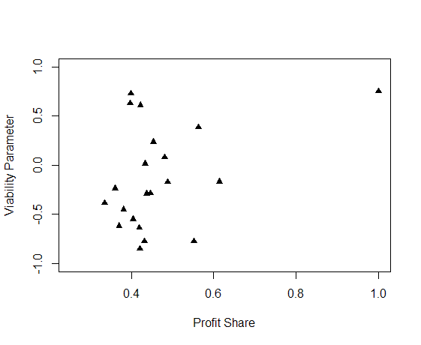

The results above are as expected. With the exception of one our two countries touching the 45degree line. All other countries are spread throughout the area. Expressing the idea that productivity of labor is not equal to wage (π,π*) . This is not surprise to us but rather a confirmation with our own data.

**R-Stan Results**

Running the MCMC linear regression we can see β0 + β1πi+εi . The peaks of a Density Plot help display where values are concentrated over the interval. For our analysis this is important when looking at $π$ give us visual of what profit share was and how it has spread significantly out from π=0 where we would have seen a perfect continuity between the wage and productivity.

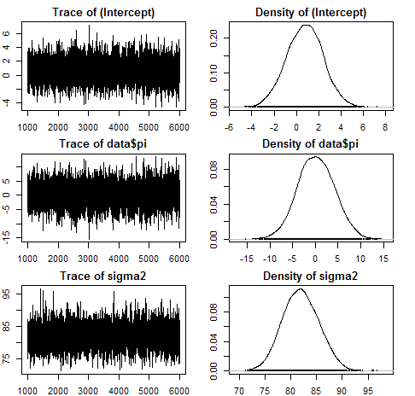

Running R-Stan we are able to make some better use of our data by understanding our variables its effect on our data set. Using a Markov Chain Monte Carlo method known as Hamiltonian Monte Carlo we have the ability to obtain a swquence of random samples from a probability distribution. We will be running a random sample due to the difficulty of doing actual samples. In our model we run 8,000 interations with 3 chains. The purpose of running the 15,000 interations it gave us a big enough sampeling size to see where the data converges after multiple samples. With our sampeling we burn the first half samples in order to eliminate any biases presented from the start of the data. After the burned data is removed it leaves us with 7,500 samples that are ran 3 times giving us 22,500 iterations of useful data.

**R-Stan Rusults**

**mean SEmean sd 2.5% 25% 50% 75% 97.5% n_eff Rhat**

**beta0 0.023 0.000 0.004 0.015 0.020 0.023 0.025 0.031 6686 1**

**beta1 0.943 0.000 0.010 0.923 0.936 0.943 0.950 0.963 6613 1**

**sigma 0.023 0.000 0.000 0.022 0.022 0.023 0.023 0.024 10430 1**

**lp__ 3642.6 0.015 1.249 3639.4 3642.0 3642.9 3643.5 3644.0 7007 1**

in our study we are searching for profit share. The calculations done in figure 1b are resuts calculated under the simulation. The density plot shows that $π_{}^{*}$

The results produced show a similar result to our our original linear model. We the results show that there is a constantly negative profit share. We can see that after running 3 chains of 15,000 iteration and cutting the initiall 7,500 results pulled in order to control for the initial pulls we get the results list. The results show that the stable point in our data is at -.071 after running our results over a sampling postierior.

*Table 6: Summary statisitics from running R-Stan simulation of profit share*

**mean SEmean sd 2.5% 25% 50% 75% 97.5% n_eff Rhat**

**beta0 0.679 0.006 0.910 -1.097 0.068 0.676 1.289 2.476 22500 1**

**beta1 -0.071 0.000 0.030 -0.130 -0.091 -0.071 -0.051 -0.013 22500 1**

**sigma 30.235 0.004 0.648 28.997 29.795 30.228 30.665 31.518 22500 1**

**lp__ -4327.0 0.012 1.242 - 4330.2 -4327.5 -4326.7 -4326.1 -4325.6 11592 1**

*Figure 9: Traceplot and Density table*

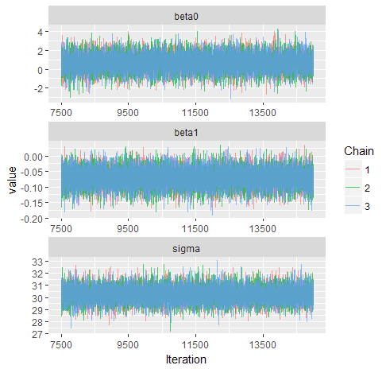

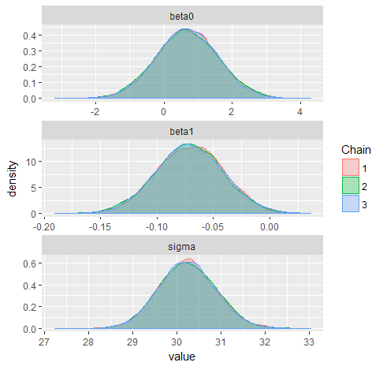

From our results we can conclude that our initial results produced in firgure (1) showing the profit shared ploted the viability parameter will continue to stray from $π=0$. provide further evidence there there is a contiuning serpration in pay comapred to profit share. In figure 7 we have other significant analytical tools that are able to be used to determine the certainty of our data. The running mean and the autocorrelation graph are some of the best determininates to assure we have usful data. Early in the results we can see that there is a small bit of lingering effects from the simulations initial position but we are able to see after multiple trials this disipates and we get results that stablize. This is importat to our study because it gives us the ability to see where the data converges to without having to see a real distribution. We can see with the results listed in figure 7 we converge to our Running mean early on and auto correlation

*Figure 7: Convergance graphs Running Mean and Autocorrelation*

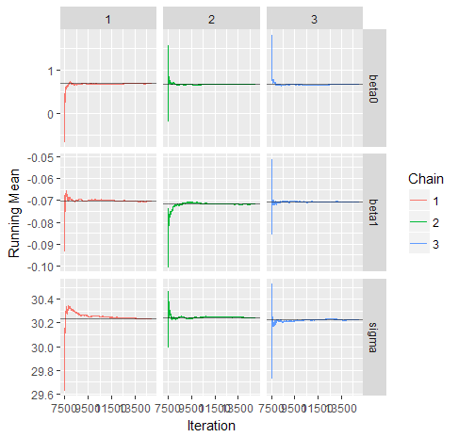

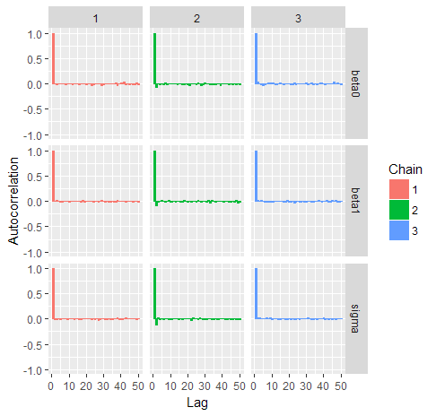

The final figure we see in figure 9 are the Geweke graph. The Geweke graph is a convergence diagnostic of MC based on the eqality of the means. The Geweke is a measurement of the Z-score. The issue we have with the graph below shows are results but there is an issue with the sigma and the first chain. It goes far outside of the of the range that is within the proper diagnosis, the area within the gray.

*Figure 9: Geweke Diagnostics*

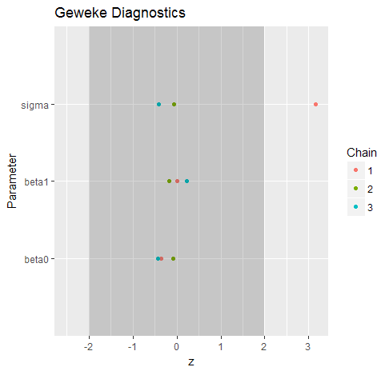

From what we have found with our R-stan results we can say that it gives us better supporting evidence of the findings by Foley and Michel (1999), while our simple linear regressions were a bad use of analytics due to the lack of our data being linear with this type of analysis we are able to see that the original hypothesis holds; showing that profit share is not equal to 0.

**Linear models**

We test H0 : β = 0; b1 = 1; b2 = 0; b3 = 0; this is equivalent to testing that E[π*|π] = π. failure to reject the null would lend support to the neoclassical view, while rejecting the null would provide evidence against it or rather support the idea that it is in the short run Basu (2009).

The goal of our linear regression is to find the best estimates for βo,β1, β3,β4 by minimizing the residual error between the experimental and predicted Profit Share. We test this by producing the model.

β0 + β1πi+εi

*Figure 10*



Dependent variable: $π_{i}^{*}$

|  |  |  |  |  |  |
| --- | --- | --- | --- | --- | --- |
|  | *Coefficient* | *Std. Error* | *t-ratio* | *p-value* |  |
| constant | −0.638921 | 0.164554 | −3.883 | 0.0001 | *** |
| π | 0.859004 | 0.413520 | 2.077 | 0.0380 | ** |

|  |  |  |  |  |
| --- | --- | --- | --- | --- |
| Mean dependent var | −0.302569 |  | S.D. dependent var | 0.933391 |
| Sum squared resid | 874.4414 |  | S.E. of regression | 0.931860 |
| R-squared | 0.004267 |  | Adjusted R-squared | 0.003278 |
| F(1, 1007) | 4.315176 |  | P-value(F) | 0.038027 |

Linear model created where $π_{i}^{*}=β_{0}+β_{1}π_{i}$

Running our regression model we can see that π is significant to $π_{i}^{*}$. We expected these results but with our next model we have added variables to be sure the margin error goes down. This is due to only using OECD countries and adding fertility to the weight on $π_{i}^{*}$. As explained by (Foley and Michl (1999) These two variables; the average labor productivity and the average fertility rate, can be expected to be highly correlated with the depth of capitalist development across countries; advanced capitalist countries can be generally expected to have high labour productivity and low fertility rates, whereas countries that have not witnessed broad-based capitalist development will generally have low labour productivity and high fertility rates

In our next model we restricted our model to only measure countries that are part of the OECD. We also add in the variable fertility state in Foley and Michel (1999), Basu(2010), Tavani (2017) to be a measurement of growth in a nation We include labor productivity and fertility rates as regressors in order to control for economic developing countries as well as the demographic transition: highly developed economies tend to be characterized by low fertility and high labor productivity, while developing economies tend to display high fertility and low labor productivity Basu (2009)

$$π_{i}^{*}= β_{0} + β_{1}π_{i} + β_{2}Fertility$$

*Figure 11:*

Dependent variable: $π_{i}^{*}$

|  |  |  |  |  |  |
| --- | --- | --- | --- | --- | --- |
|  | *Coefficient* | *Std. Error* | *t-ratio* | *p-value* |  |
| constant | −0.656044 | 0.170626 | −3.845 | 0.0001 | *** |
| π | 0.820501 | 0.425813 | 1.927 | 0.0543 | * |
| Fertility | 0.0173799 | 0.0455281 | 0.3817 | 0.7027 |  |

|  |  |  |  |  |
| --- | --- | --- | --- | --- |
| Mean dependent var | −0.302569 |  | S.D. dependent var | 0.933391 |
| Sum squared resid | 874.3147 |  | S.E. of regression | 0.932255 |
| R-squared | 0.004411 |  | Adjusted R-squared | 0.002432 |
| F(2, 1006) | 2.228620 |  | P-value(F) | 0.108208 |

The new linear model created where $π_{i}^{*}=β_{0}+β_{1}π_{i}+β_{2}Fertility$

Looking at the results above the significance level is our first concern with the data listed. Fertility is showing to have no significant effect on the model. While the significance of π has become less significant as well in this model.

The results from the results above are difficult to accept as explained by Basu (2009) the argument relies on a stochastic argument. In recognizing that π* and π are random variable, because they are effected by many stochastic impulses from pressure in the macro economy. Fertility and profit share both being random in a large scale environment is hard to measure against a stagnant variable so, this appears to be the problem we are running into.

Unlike Basu we will not add in African countries to our data this is due to OECD countries having a unified goal to promote policies that will improve the economic and social well-being of people around the world. Through our analysis we expect these countries alone to show comparable date due to globalization and its effect on countries that are attempting to collaborate on economic policies.

$$π_{i}^{*}=β_{0}+β_{1}π_{i}+β_{2}{Labor Productivity}_{i}+β_{2}{Fertility}_{i}+ε_{i}$$

Figure 12:

Dependent variable: $π_{i}^{*}$

|  |  |  |  |  |  |
| --- | --- | --- | --- | --- | --- |
|  | *Coefficient* | *Std. Error* | *t-ratio* | *p-value* |  |
| constant | −0.663075 | 0.171987 | −3.855 | 0.0001 | *** |
| π | 0.824493 | 0.426168 | 1.935 | 0.0533 | * |
| Labor Productivity | 0.00000 | 0.00000 | 0.3349 | 0.7378 |  |
| Fertility | 0.0177072 | 0.0455587 | 0.3887 | 0.6976 |  |

|  |  |  |  |  |
| --- | --- | --- | --- | --- |
| Mean dependent var | −0.302569 |  | S.D. dependent var | 0.933391 |
| Sum squared resid | 874.2172 |  | S.E. of regression | 0.932667 |
| R-squared | 0.004522 |  | Adjusted R-squared | 0.001551 |
| F(3, 1005) | 1.521819 |  | P-value(F) | 0.207229 |

Our last model we look at $π_{i}^{*}=β_{0}+β_{1}π_{i}+β_{2}{Labor Productivity}_{i}+β_{2}{Fertility}_{i}+ε_{i}$

The model above is introduced by Basu (2009). His argument for using these two additional variables Labor productivity and Fertility is due to the expectation that they would be highly correlated. Under the expectation that advanced capitalist countries generally expect to have high labor productivity and low fertility rates, while it is expected to be just the opposite.

Over all just as Foley and Michl (1999); Basu (2000) our results do not show that Labor productivity or Fertility have a significant amount of inference on our linear model. For that reason I go to say yes the results do support $π≤π^{*}$ the Marx point of view but rather than rejecting null hypothesis. I would call the test inconclusive. With the parameters introduced in this analysis we were unable to measure accurately what was effecting the viable parameter.

**Comparing results:**

The results produced by me are based off OECD countries. The data provided from the (NWPT 6.0) shows us results from 34 countries that have supporting data, this is 6 more countries measured beyond Basu’s 28 country measurement. Our results also show 14 more years of data than the original test done by Foley and Michel (1999). With this in mind we expect some variations in our results. Producing the linear models alongside the hierarchical models has helped us to see that the data that is produced is not linear. With this we are seeing high significance in our variables we are measuring but low R-squareds. This is result to our data not being linear and not that the hypothesis we are testing is faulty. In the regression the Y intercept is lower and the profit share is slightly higher than results produced by Basu. This difference should not spark too much surprise do to us understanding the rise of technology post 2000.

To conclude, there is not enough evidence to reject the hypothesis but we have also discovered it is hard to find a viable measurement of what is affecting the viable parameter when using the linear regression method. Using the Stan modeling has provided us with enough information to say that our data is truly significant as it converges early on when we are running multiple trials.

|  |  |  |  |  |
| --- | --- | --- | --- | --- |
| Summary Statistics OECD Countries (1963-2016) | | | | |
|  | Mean | Median | Max | Min |
| Fertility | 2.017 | 1.800 | 6.831 | 1.076 |
| Profit Share (pi) | 0.4139 | 0.3795 | 1.000 | .2440 |
| Labor Productivity (xpp2011) | 53264 | 51841 | 131087 | 6999 |
| Viability Parameter (pistari) | .8792 | .6840 | 148.86 | -146.23 |
| Capital Productivity (pistar) | .7818 | .3393 | 611.95 | -387.18 |

References

Basu, D. (2009). MARX-BIASED TECHNICAL CHANGE AND THE NEOCLASSICAL VIEW OF INCOME DISTRIBUTION. *Metroeconomica*, 61(4), pp.593-620.

Basu, D. and Foley, D. (2013). Dynamics of output and employment in the US economy. *Cambridge Journal of Economics*, 37(5), pp.1077-1106.

CAMPBELL, T. and TAVANI, D. (2017). Marx-biased Technical Change and Income Distribution: a Panel Data Analysis. [online] Available at: https://www.researchgate.net/publication/320564363 [Accessed 28 Nov. 2017].

Gordon, R. (2017). *Okun's Law and Productivity Innovations*. [online] Available at: http://www.aeaweb.org/articles.php?doi=10.1257/aer.100.2.11 [Accessed 28 Nov. 2017].

Kaldor, N. (1968). Productivity and Growth in Manufacturing Industry: A Reply. *Economica*, 35(140), p.385.

Marquetti, A. (2003). Analyzing historical and regional patterns of technical change from a classical-Marxian perspective. *Journal of Economic Behavior & Organization*, 52(2), pp.191-200.

Villanueva, L. (2015). Connecting Patterns of Technical Change and Income Inequality. *International Journal of Political Economy*, [online] 44(2), pp.121-141. Available at: https://www.researchgate.net/publication/283004705.

Yang, J. (2016). A Bayesian Multiple Frontier Estimation in the Probabilistic Induced Technical Change Model: OECD Countries from.